Criteria B – Planning
Table of Contents
1. Design Overview 3
1.1. Structured Chart 3
1.2. System Flowchart 4
2. Database Schema 4
2.1. Database Dictionary 4
2.2. Database Normalization: 7
2.3. Entity Relationship Diagram 9
3. Prototypes 9
3.1. Login Page 10
3.2. Register Page 14
3.3. Forgot Password Page 16
3.4. Home Page 18
3.5. Product Page 20
3.6. Edit Product Page 22
3.7. Delete Product Page 24
3.8. Transaction Flow Page 26
3.9. Transaction List Page 29
3.10. Edit Transaction Page 31
3.11. Delete Transaction Page 37
3.12. Change Password Page 40
4. Test Plan: 44

No | Figure Index | Page No
1 | Structured Flowchart of the Streamliner Application | 3
2 | System Flowchart for Streamliner | 4
3 | ERD of Streamliner | 9
4 | The Data Flow Diagram Legend/Key | 9
5 | Data flow and Design Annotations for Login Page | 10
6 | Data flow and Design Annotations for Register Page | 14
7 | Data flow and Design Annotations for Forgot Password Page | 16
8 | Data flow and Design Annotations for Home Page | 18
9 | Data flow and Design Annotations for Product Page | 20
10 | Data flow and Design Annotations for Edit Product Page | 22
11 | Data flow and Design Annotations for Delete Product Page | 24
12 | Data flow and Design Annotations for Transaction Flow Page | 26
13 | Data flow and Design Annotations for Transaction List Page | 29
14 | Data flow and Design Annotations for Edit Transaction Page | 31
15 | Data flow and Design Annotations for Delete Transaction Page | 37
16 | Data flow and Design Annotations for Change Password Page | 40

Design Overview

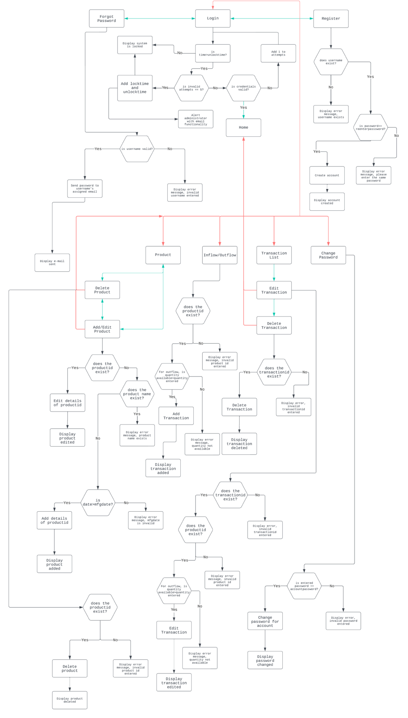
Structured Chart
Figure 1: Structured Flowchart of the Streamliner Application

System Flowchart
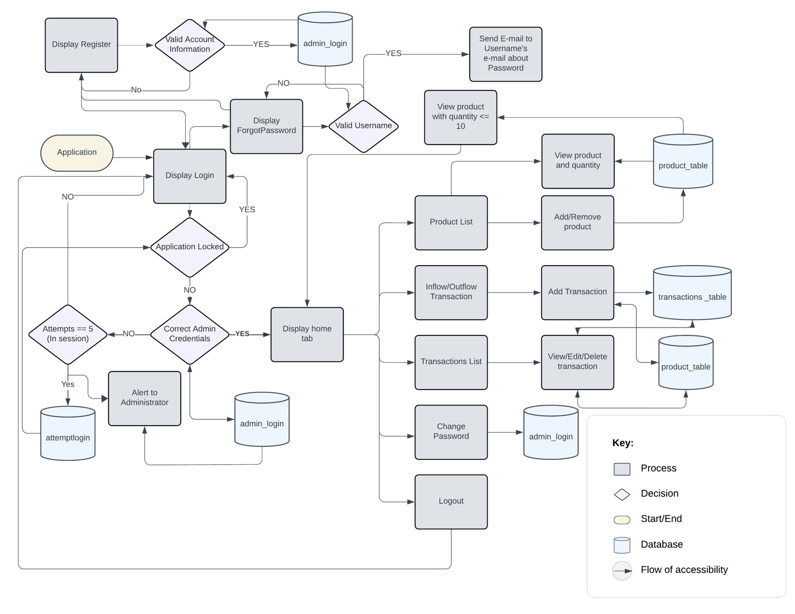
Figure 2: System Flowchart for Streamliner

Database Schema

Database Dictionary
Column Name: | Type: | Size: | Constraint: | Description with Example:
Userid | INT | 10 | PRIMARY_KEY  AUTO_INCREMENT | Generates an integer value or id for each account created.  E.g. Userid: 50
Username | VARCHAR | 255 | UNIQUE | Every account will have a unique name so staff can have their own accounts and login.  E.g. Username: JohnDoe
Password | VARCHAR | 255 | Not NULL | A protection field to ensure authorized users access their respective accounts.  E.g. Password: Cs12345!
Email | VARCHAR | 255 | UNIQUE | Holds e-mail id to ensure an authorized account is created and useful in case of password retrieval.  E.g. Password: johndoecs12345@gmail.com
unlocktime | VARCHAR | 50 | Not NULL | Unlock time will dictate the time at which the application will unlock if the application has been locked due to 5 consecutive incorrect attempts.  E.g. unlocktime: 18/1/2023 14:55:23
locktime | VARCHAR | 50 | Not NULL | locktime will record the exact time and date at which the application becomes locked when 5 incorrect consecutive attempts are made.  E.g. locktime: 18/1/2023 14:25:23
productid | INT | 10 | PRIMARY_KEY  FOREIGN_KEY | productid stores an integer value for each product added. Easy to retrieve information of a product and traverse the productid through the different pages.  E.g. productid: 10
productname | VARCHAR | 50 | Unique | productname stores the name of each product/good in the system.  E.g. productname: Apples
quantity | INT | 10 |  | quantity stores the integer value of the stock left for each good.  E.g. quantity: 15
mfgdate | VARCHAR | 50 | Not NULL | Mfgdate stores the manufacturing date of each product.  E.g. mfgdate: 25/02/2023
price | FLOAT | 12 | Not NULL | Price stores the price of one unit of a product, with an ability to be whole number or a float.  E.g. price: 10.2
transactionsid | INT | 10 | PRIMARY_KEY  AUTO_INCREMENT | Transactionsid generates a transactionid for each transaction made in the application.  E.g. transactionsid: 40
transactiondate | VARCHAR | 255 | Not NULL | Transactionsdate records the date and time of transaction.  E.g. transactiondate: 12/04/2023 12:01:20
transactiontype | VARCHAR | 30 | Not NULL | Transactiontype records the flow of transaction, whether it is inflow (I) or outflow (O).  E.g. transactiontype: I

Database Normalization:
    - 1NF:
admin_login:
Userid: integer(10) – Primary Key
Username: varchar(255)
Password: varchar(255)
Email: varchar(255)

attemptlogin:
locktime: varchar(50)
unlocktime: varchar(50)

product_table:
productid: integer(10) - Primary Key
productname: varchar(50)
quantity: integer(3)
mfgdate: varchar(20)
price: float(12)

    - 2NF:
admin_login:
Userid: integer(10) – Primary Key
Username: varchar(255)
Password: varchar(255)
Email: varchar(255)

attemptlogin:
locktime: varchar(50)
unlocktime: varchar(50)

product_table:
productid: integer(10) - Primary Key
productname: varchar(50)
quantity: integer(10)
mfgdate: varchar(20)
price: float(12)

transactions_table:
transactionid: integer(10)
transactiondate: varchar(255)
transactiontype: varchar(30)
productid: integer(3) – Foreign Key

Entity Relationship Diagram
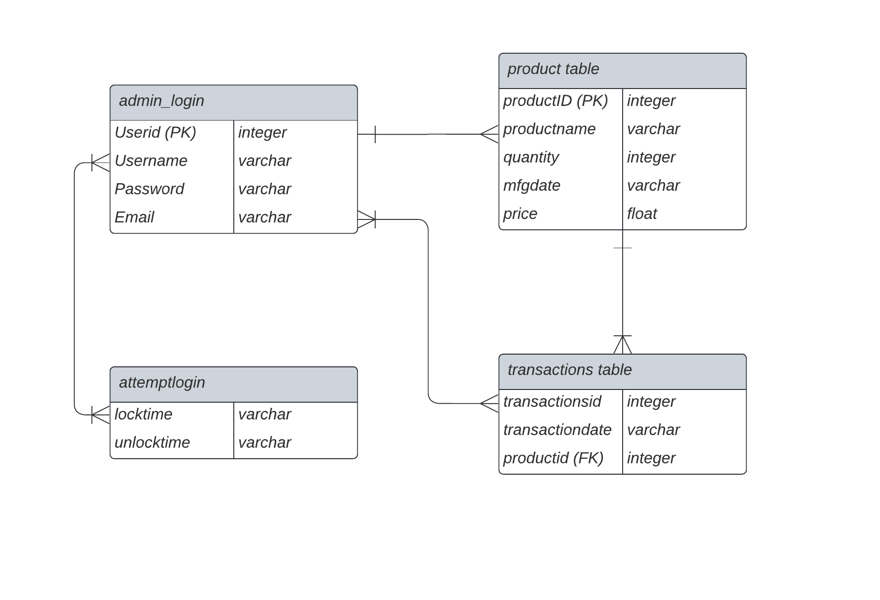
Figure 3: ERD of Streamliner

Prototypes
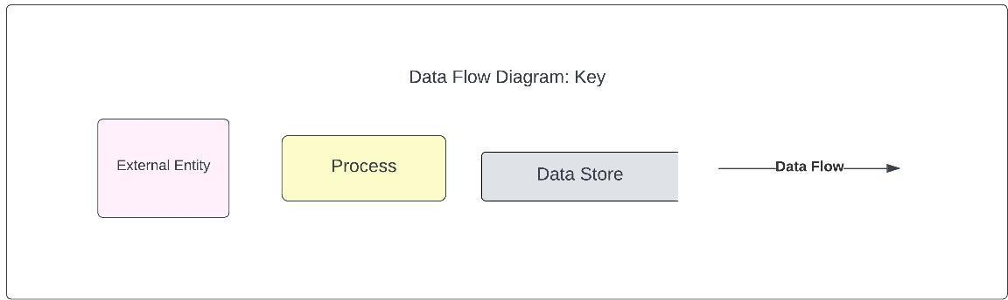
Figure 4: The Data Flow Diagram Legend/Key

Login Page
    - Diagrams and Annotations
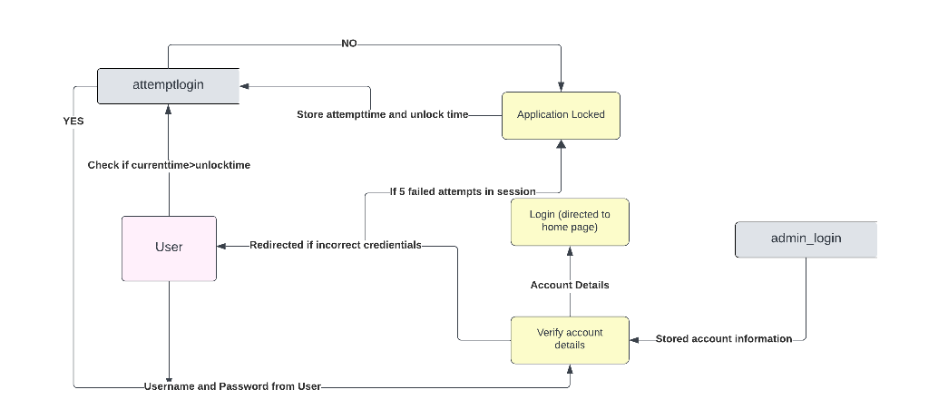
  Name: | Description:
  nameTxt | User enters the name of the account in this text field
  passwordTxt | User enters password of the account in this text field
  loginBtn | When clicked, the information provided by user will be checked against (verified) with account details in the database.
  forgotpasswordBtn | Clicking button will direct user to “Forgot Password” tab.
  registerBtn | Clicking button will direct user to “Register” tab.
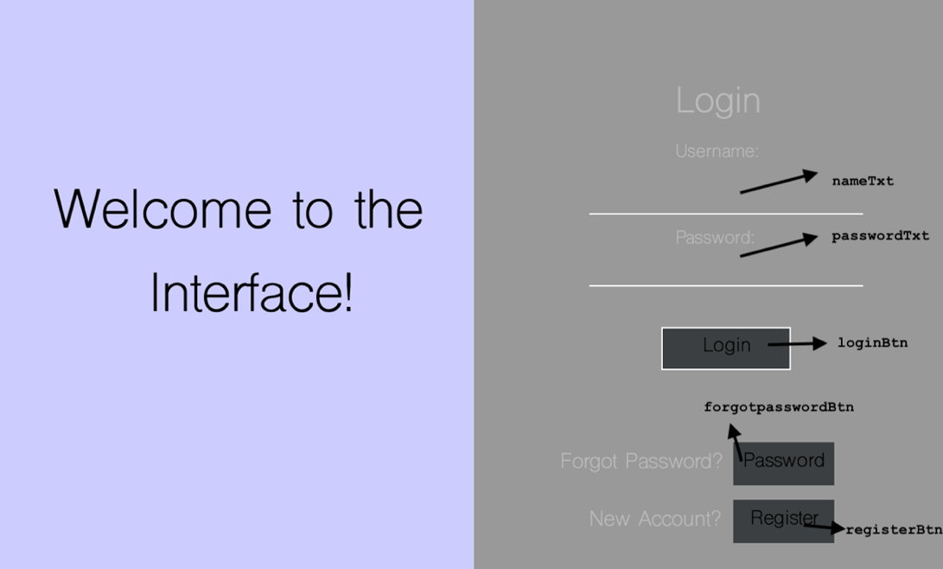
Figure 5: Data flow and Design Annotations for Login Page
    - Pseudocode
if min >= 60 {
newminutes = min - 60
newminute = convertToString(newminutes)
if newminutes < 10 {
newminute = "0" + newminute
}
hour = convertToInt(hours)
hour = hour + 1
newhour = convertToString(hour)
if hour < 10 {
newhour = "0" + newhour
}
if hour >= 24 {
hour = hour - 24
newhour = convertToString(hour)
if hour < 10 {
newhour = "0" + hour
}
inidays = inidays + 1
print(inidays)
switch inimonth {
case 1:
if inidays > 31 {
inidays = inidays - 31
inimonth = inimonth + 1
}
case 2:
if iniyear % 4 == 0 {
if inidays > 29 {
inidays = inidays - 29
inimonth = inimonth + 1
}
} else {
if inidays > 28 {
inidays = inidays - 28
inimonth = inimonth + 1
}
}
case 3:
if inidays > 31 {
inidays = inidays - 31
inimonth = inimonth + 1
}
case 4:
if inidays > 30 {
inidays = inidays - 30
inimonth = inimonth + 1
}
case 5:
if inidays > 31 {
inidays = inidays - 31
inimonth = inimonth + 1
}
case 6:
if inidays > 30 {
inidays = inidays - 30
inimonth = inimonth + 1
}
case 7:
if inidays > 31 {
inidays = inidays - 31
inimonth = inimonth + 1
}
case 8:
if inidays > 31 {
inidays = inidays - 31
inimonth = inimonth + 1
}
case 9:
if inidays > 30 {
inidays = inidays - 30
inimonth = inimonth + 1
}
case 10:
if inidays > 31 {
inidays = inidays - 31
inimonth = inimonth + 1
}
case 11:
if inidays > 30 {
inidays = inidays - 30
inimonth = inimonth + 1
}
case 12:
if inidays > 31 {
inidays = inidays - 31
inimonth = inimonth + 1
}
}
if inimonth > 12 {
iniyear = iniyear + 1
}
finaldays = convertToString(inidays)
if inidays < 10 {
finaldays = ""
finaldays = finaldays.concat("0" + inidays)
}
}
}

Register Page
    - Diagrams and Annotations
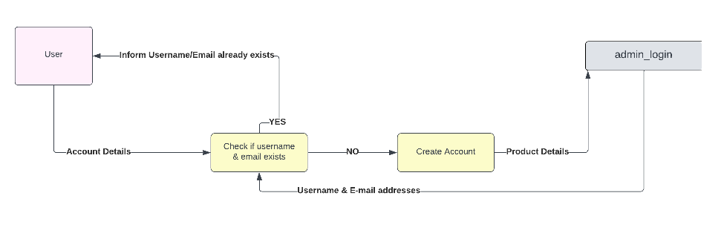
  Name: | Description:
  nameTxt | User enters their preferred username for their account
  passwordTxt | User enters desired password for their account
  reenterpasswordTxt | User re-enters desired password for their account
  emailTxt | User enters their email address which they would like to link their account with.
  registerBtn | Will take details from all JTextFields and create an account (insert values to database table, admin_table)
  loginBtn | This button when clicked will redirect user  back to “Login tab”
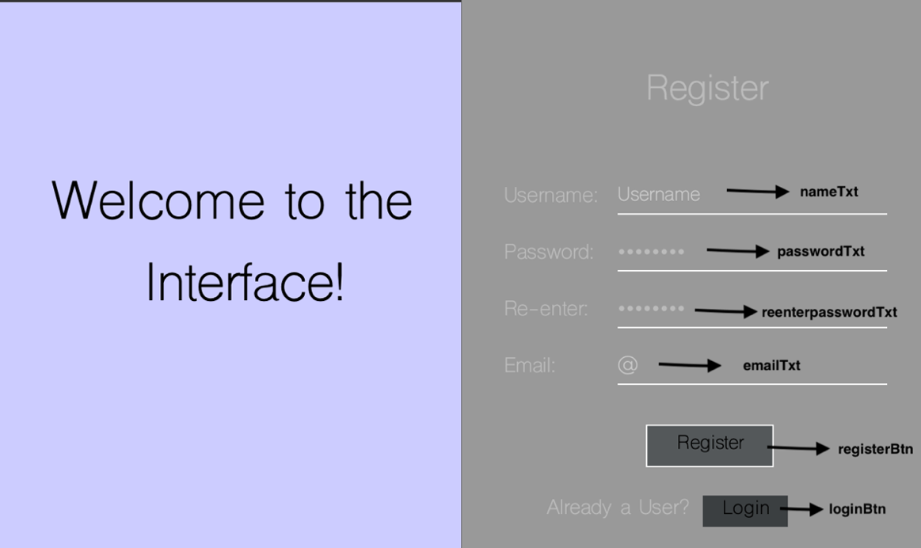
Figure 6: Data flow and Design Annotations for Register Page
    - Pseudocode
if password equals repassword then
// check if username exists
String getUsernameQuery = "SELECT * FROM admin_table WHERE Username='" + username + "';"
pstatement = con.prepareStatement(getUsernameQuery)
rset = pstatement.executeQuery()
if rset.next() then
resultLbl.setText("Username Taken")
else
// check if email exists
String getEmailQuery = "SELECT * FROM admin_table WHERE Email='" + email + "';"
pstatement1 = con.prepareStatement(getEmailQuery)
rset1 = pstatement1.executeQuery()
if rset1.next() then
resultLbl.setText("E-mail already in use")
else
// insert details and create the account
String insertQuery = "INSERT INTO admin_table (Username, Password, Email) VALUES ('" + username + "','" + password + "','" + email + "');"
statement = con.createStatement()
statement.executeUpdate(insertQuery)
showMessageBox("Successfully Registered.")
StreamlinerLog.init()
statement.close()
con.close()
end if
end if
else
// Invalid login
resultLbl.setText("Re-entered Password is different")
end if

Forgot Password Page
    - Diagrams and Annotations

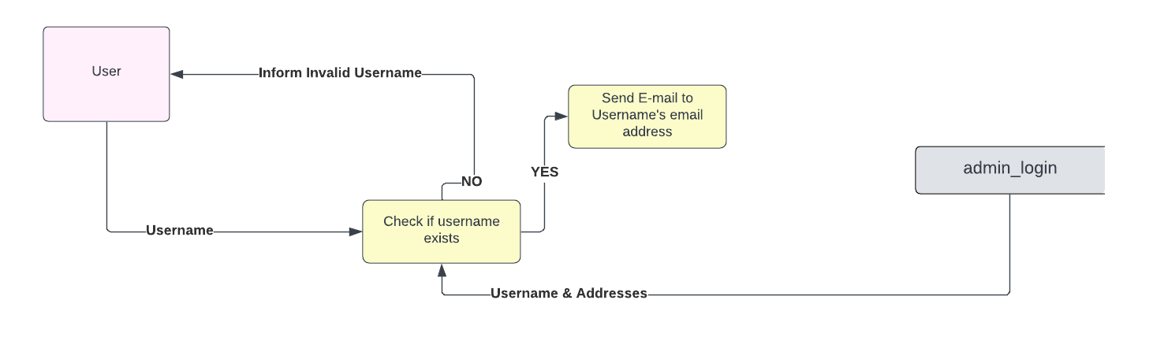
  Name: | Description:
  nameTxt | User enters their preferred username for their account
  forgotpasswordBtn | When pressed,  e-mail will be sent to the email address connected with the username regarding their password
  registerBtn | Button redirects user to register page
  loginBtn | Button redirects user to login page
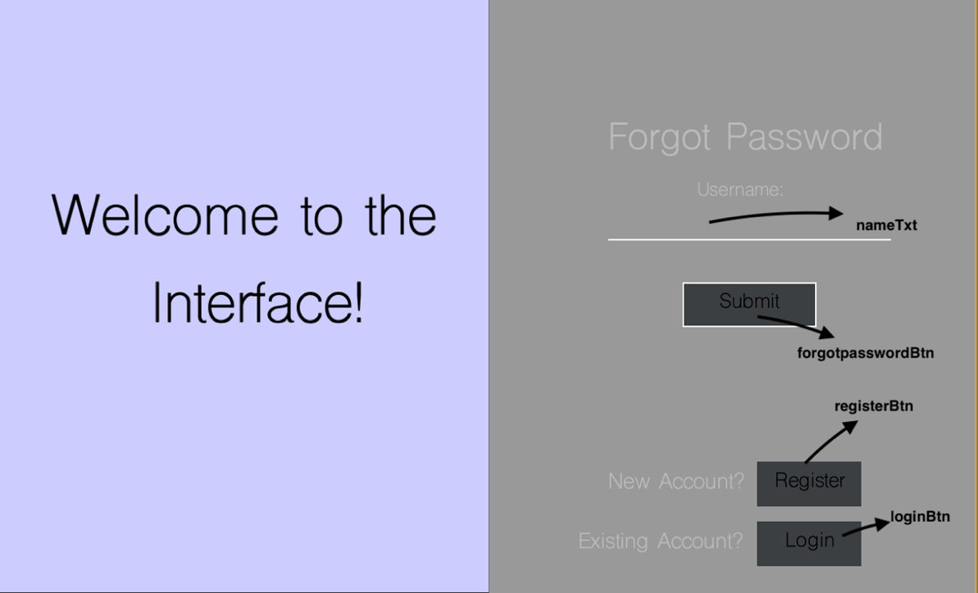
Figure 7: Data flow and Design Annotations for Forgot Password Page
    - Pseudocode
resultLbl.setText("") // Clear previous messages
String username = nameTxt.getText()
// Check if the username exists
String emailCheckQuery = "SELECT * FROM admin_table WHERE Username='" + username + "';"
pstatement = con.prepareStatement(emailCheckQuery)
rset = pstatement.executeQuery()

if rset.next() then
// Retrieve email and password for the given username
String useremail = rset.getString("Email")
String password = rset.getString("Password")

// Send the password to the user's email using the Emailsend class
Emailsend.sendEmail(useremail, password)

// Display success message
showMessageBox("Password sent to respective E-mail address.")
end if
else
// Invalid username provided
resultLbl.setText("Invalid Username Provided")
StreamlinerLog.init()
StreamlinerLog.logger.log(Level.WARNING, "Exception ::", e)

Home Page
    - Diagrams and Annotations

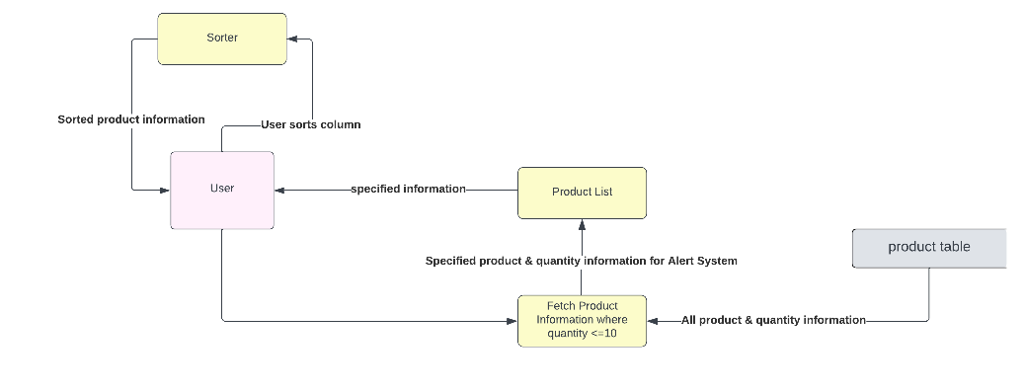
  Name: | Description:
  homeBtn | When clicking the button, it will return the  user to “Home tab”.
  productBtn | When clicking the button, the program will  show the “Product List” tab to the user.
  flowBtn | When the button is clicked, it will direct you  to the “Inflow/Outflow Transaction Tab”
  transactionBtn | This button when clicked will show the  “Transaction List tab”.
  changepasswordBtn | The changepasswordBtn will redirect user to “Change Password tab”.
  alertqty_Table | Table provides products which have quantity less than or equal to 10 units.
  logoutBtn | This button when clicked will redirect user
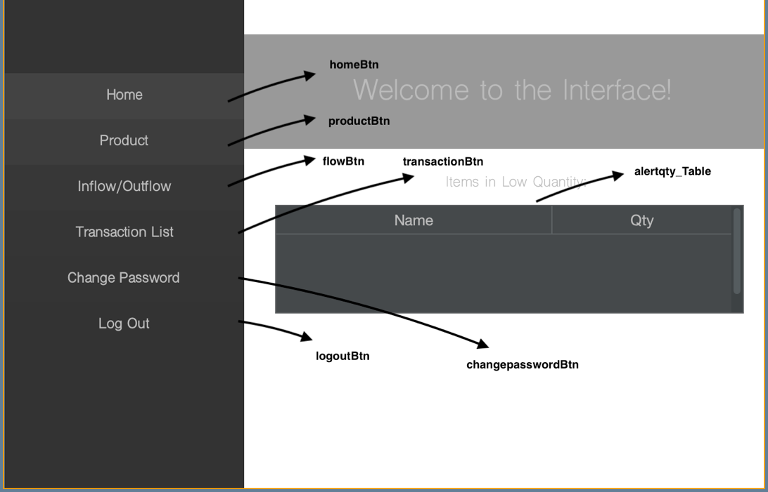
Figure 8: Data flow and Design Annotations for Home Page
    - Pseudocode
// Get the table model
DefaultTableModel tblModel = (DefaultTableModel)alertqty_table.getModel()
statement = con.createStatement()
String sql = "SELECT * FROM product_table;"
rset = statement.executeQuery(sql)
// Clear existing rows in the table model
while tblModel.getRowCount() > 0
tblModel.removeRow(0)

// Iterate through the result set and add products with quantity less than 11 to the table
while rset.next()
String productname = rset.getString("productname")
String qty = rset.getString("quantity")
Integer quantity = Integer.parseInt(qty)

if quantity < 11 then
Object tbData[] = {productname, quantity}
tblModel.addRow(tbData)
end if
end while

// Close the statement
statement.close()

Product Page
    - Diagrams and Annotations

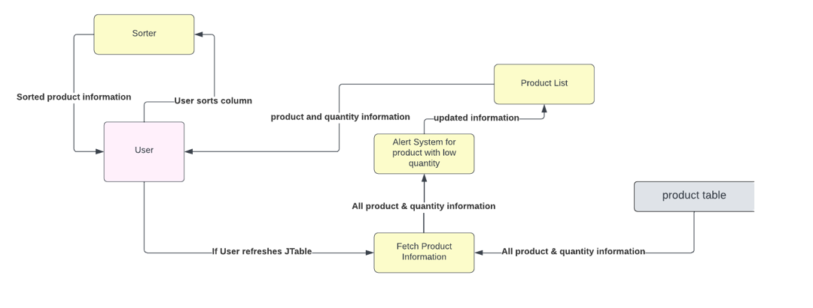
  Name: | Description:
  editproductpageBtn | The button will allow user to access “Add/Edit Product” page where user can  accordingly add or change a product.
  product_table | Displays all data present in the database product table
  refreshBtn | Refreshes product_table to display contents
  deleteproductpageBtn | Button will allow user to access “Delete Product” tab where user can delete a product
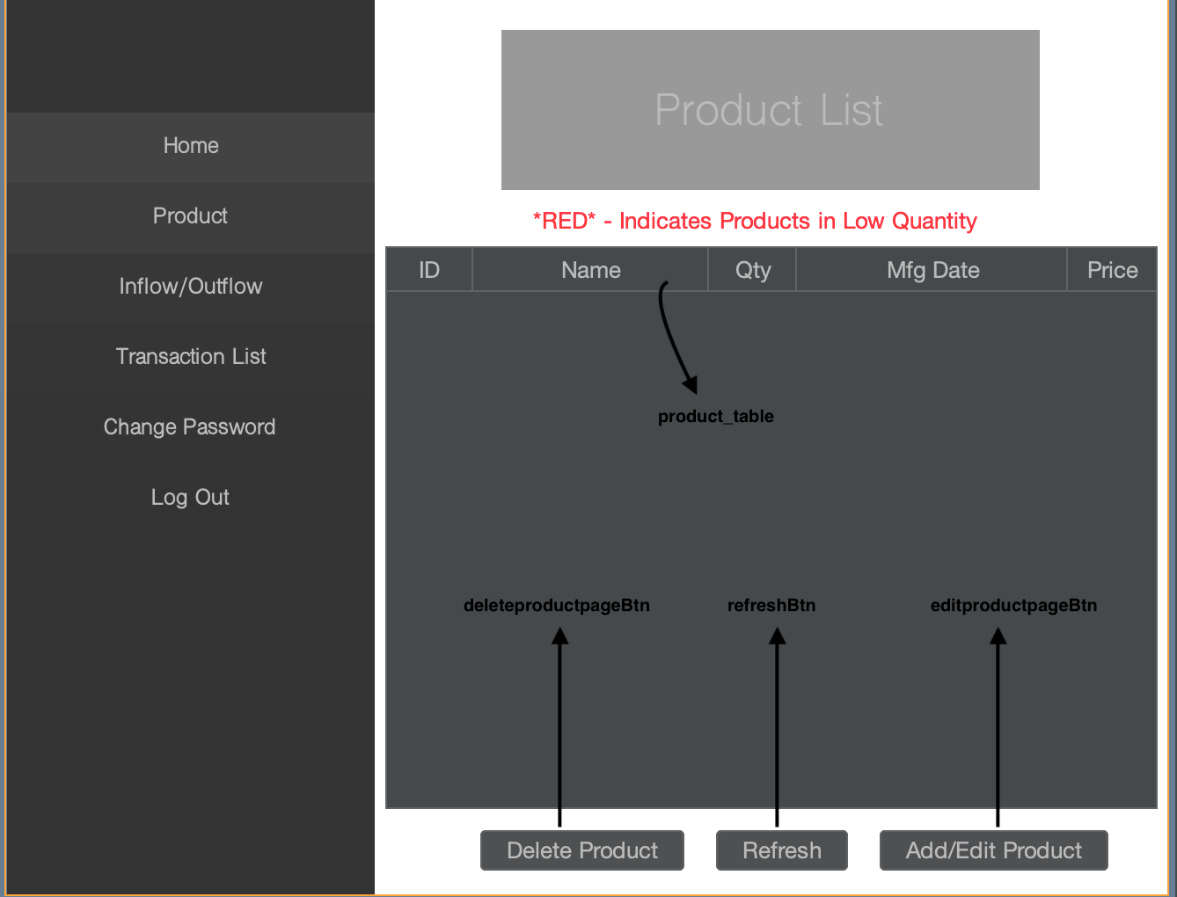
Figure 9: Data flow and Design Annotations for Product Page
    - Pseudocode
tblModel = product_table.getModel()

productColumn = product_table.getColumn("Qty")
productColumn.setCellRenderer(
new DefaultTableCellRenderer() {
originalColor = null

function getTableCellRendererComponent(table, value, isSelected, hasFocus, row, column)
renderer = super.getTableCellRendererComponent(table, value, isSelected, hasFocus, row, column)

if originalColor == null then
originalColor = getForeground()
end if

quantity = cast(value, Integer)

if quantity < 11 then
renderer.setForeground(Color.RED)
else
renderer.setForeground(originalColor) // Restore original color
end if

return renderer
end function
}
)

Edit Product Page
    - Diagrams and Annotations

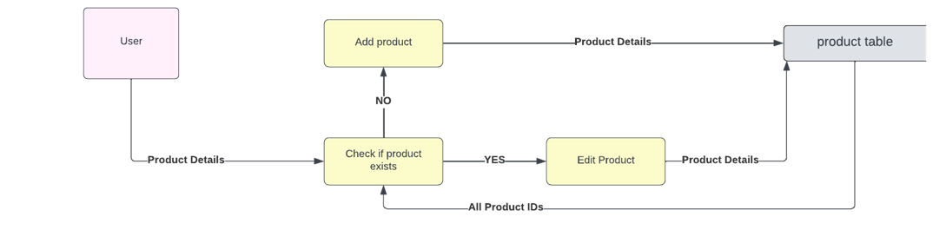
  Name: | Description:
  productdeletepageBtn | The button when clicked will direct user to  “Delete Product” page.
  productnameTxt | The user should enter the name of the product which is assigned to the respective  product id in the given text-field.
  productdateTxt | Allows user to add manufacturing date for product.
  productpriceTxt | Allows user to add price of respective product.
  productidTxt | The user should write a new product id if a new product is to be added or write the product id of the product that is to be edited  in this text-field.
  producteditBtn | This button when clicked will upload the provided information (add or overwrite)  onto the database.
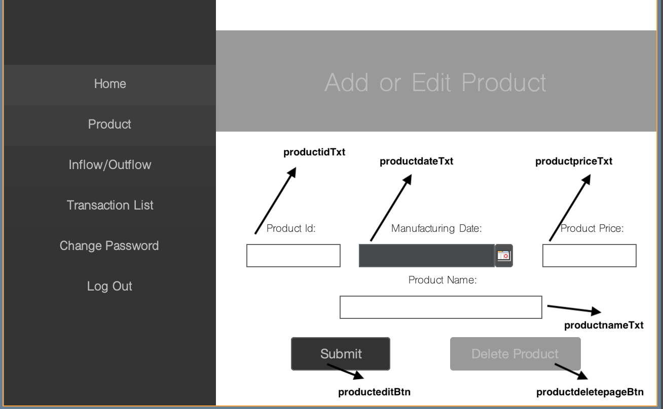
Figure 10: Data flow and Design Annotations for Edit Product Page
// Initialize variables
String sql = "SELECT * FROM product_table;"
Integer count = 0
ArrayList<String> ids = new ArrayList<String>()
// Execute query to retrieve existing product IDs
pstatement = con.prepareStatement(sql)
rset = pstatement.executeQuery()

// Prepare SQL statements for adding and editing products
String add = "INSERT INTO product_table VALUES ('" + productid + "','" + productname + "','" + 0 + "','" + mfgdate + "','" + productprice + "');"
statement = con.createStatement()
String edit = "UPDATE product_table SET productname='" + productname + "', mfgdate='" + mfgdate + "', price='" + productprice + "' WHERE productid='" + productid + "';"
statement1 = con.createStatement()

// Populate the list of existing product IDs
while rset.next()
String id = rset.getString("productid")
ids.add(id)
end while
// Check if the product ID already exists
for i = 0 to ids.size() - 1
eachid = ids.get(i)
if eachid equals productid then
count = 1
end if
else
continue
end for
// If product ID exists, update the product; otherwise, add a new product
if count equals 1 then
statement1.executeUpdate(edit)
showMessageBox("Product Edited!")
statement1.close()
end if
else
statement.executeUpdate(add)
showMessageBox("Product Added")
statement.close()

Delete Product Page
    - Diagrams and Annotations

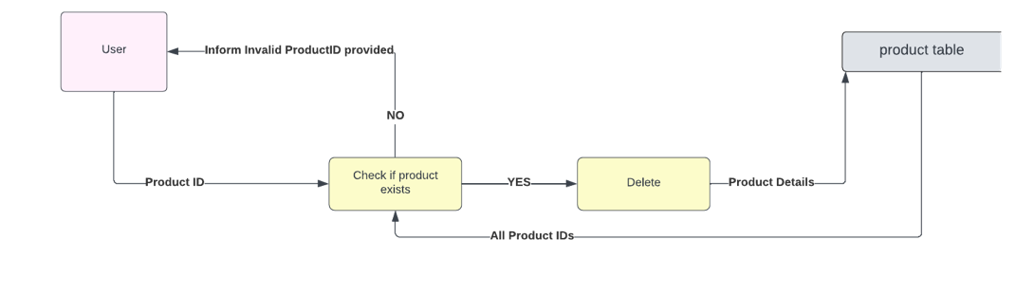
  Name: | Description:
  productdeleteBtn | When this button is clicked, the information provided will be sent to database to delete the respective product with same product id  mentioned in productidTxt.
  producteditpageBtn | When this button is clicked, it redirects user  to go to “Add/Edit Product” page.
  productidTxt | This text field is used to write the id of the product the user would like to delete from  the product list.
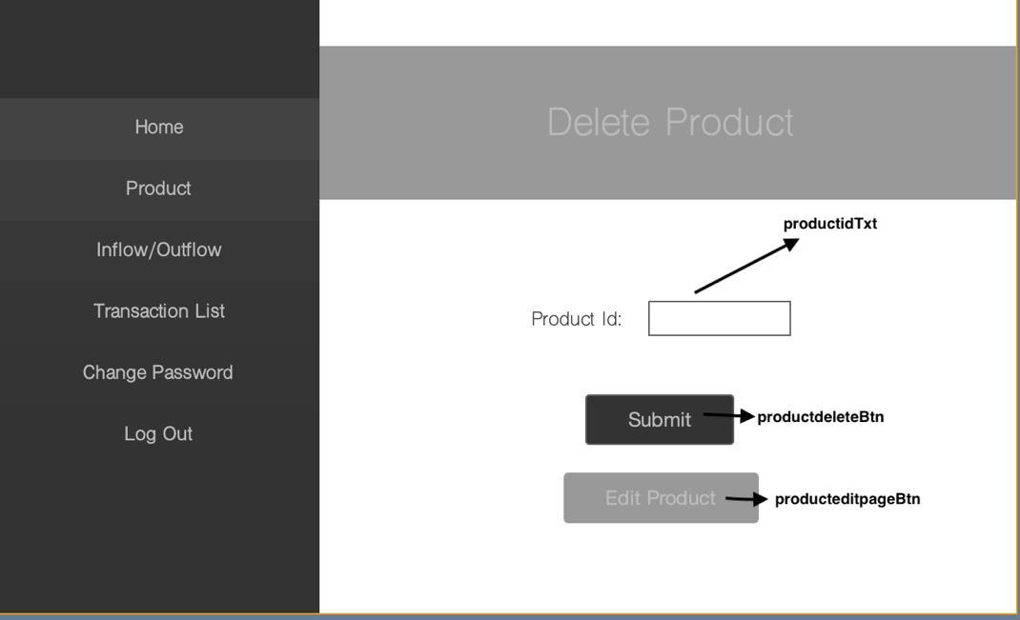
Figure 11: Data flow and Design Annotations for Delete Product Page
    - Pseudocode
// Prepare SQL statement for retrieving the product
String selectQuery = "SELECT * FROM product_table WHERE productid='" + productid + "';"
statement = con.createStatement()
rset = statement.executeQuery(selectQuery)
while rset has next row:
id = rset.getString("productid")

if productid equals id:
statement = con.createStatement()
deleteQuery = "DELETE FROM product_table WHERE productid='" + productid + "';"
statement.executeUpdate(deleteQuery)

new product(ro).setVisible(true)
setVisible(false)

// Alert the user
showMessageBox("Product Deleted!")

// Log the deletion
StreamlinerLog.init()
StreamlinerLog.logger.info("Product ID: " + productid + " is deleted by " + ro)

else:
resultLbl.setText("Please enter an existing ProductID")

Transaction Flow Page
    - Diagrams and Annotations

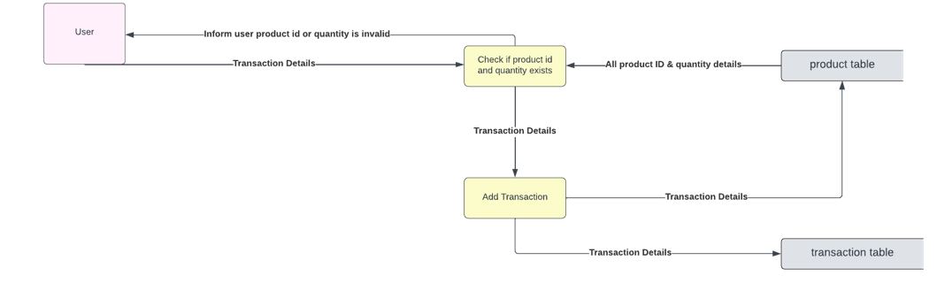
  Name: | Description:
  outflowBtn | When clicking the button, it will change the transaction to outflow where respective  product is bought/sold to user’s customer.
  inflowBtn | When clicking the button, it will change the transaction to inflow where respective  product is re-stocked by user.
  productidTxt | The user enters the productid of the product that has been sold or stocked in this text  field.
  quantityTxt | User enters the quantity of the product that  has been stocked or sold in this text field.
  transactionsubmitBtn | User clicks button to submit all data from all text fields to update respective database tables.
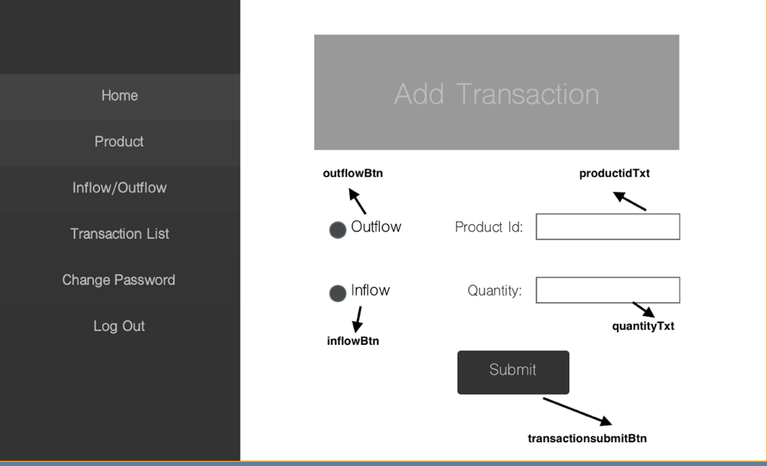
Figure 12: Data flow and Design Annotations for Transaction Flow Page
    - Pseudocode
// Prepare SQL statement for retrieving the product
String selectQuery = "SELECT * FROM product_table WHERE productid='" + productid + "';"
if rset has next row:
resultLbl.setText("")

iniqty = rset.getString("quantity")
productname = rset.getString("productname")

// Acquire information of the quantity entered and calculate new quantity for the product
initialqty = parseInt(iniqty)
finaladdqty = quantity + initialqty
finalsubqty = initialqty - quantity

if outflowBtn is selected:
if finalsubqty <= 0:
resultLbl.setText("There is not enough quantity of the product to sell.")
return
else:
// Process the sale transaction
updateQuery = "UPDATE product_table SET quantity='" + finalsubqty + "' WHERE productid='" + productid + "';"
statement = con.createStatement()
statement.executeUpdate(updateQuery)

transactionQuery = "INSERT INTO transactions_table (productid, productname, quantity, transactiondate, transactiontype) VALUES ('" + productid + "','" + productname + "','" + quantity + "','" + transactiondate + "','O');"
statement.executeUpdate(transactionQuery)

JOptionPane.showMessageDialog(null, "Transaction Processed!")
StreamlinerLog.init()
StreamlinerLog.logger.info("Transaction processed by AdminID: " + ro)

productidTxt.setText("")
quantityTxt.setText("")
end if

else if inflowBtn is selected:
// Process the restocking transaction
updateQuery = "UPDATE product_table SET quantity='" + finaladdqty + "' WHERE productid='" + productid + "';"
statement = con.createStatement()
statement.executeUpdate(updateQuery)

transactionQuery = "INSERT INTO transactions_table (productid, productname, quantity, transactiondate, transactiontype) VALUES ('" + productid + "','" + productname + "','" + quantity + "','" + transactiondate + "','I');"
statement.executeUpdate(transactionQuery)

JOptionPane.showMessageDialog(null, "Transaction Processed!")
StreamlinerLog.init()
StreamlinerLog.logger.info("Transaction processed by AdminID: " + ro)

productidTxt.setText("")
quantityTxt.setText("")
end if

else:
resultLbl.setText("Invalid ProductID entered")
end if

Transaction List Page
    - Diagrams and Annotations

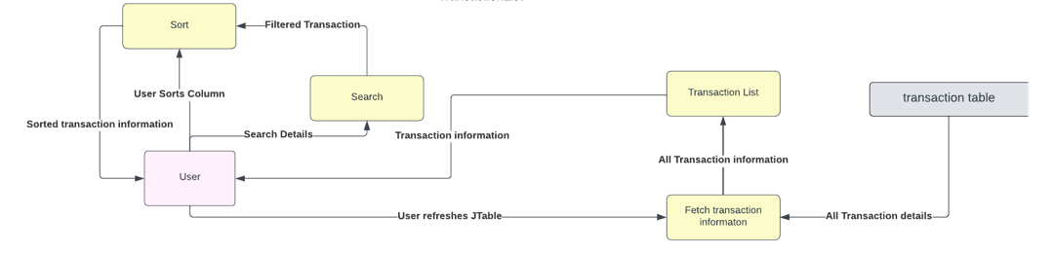
  Name: | Description:
  edittransactionBtn | This button will take the respective transaction and provide the user to the “Edit Transaction” tab to edit the respective transaction.
  refreshBtn | Refreshes transaction_table to update the contents in the JTable according to values in database table.
  transaction_table | Represents values from the database transaction table.
  searchTxt | Allows user to search the transactions for certain name products that are presented in the transaction_table.
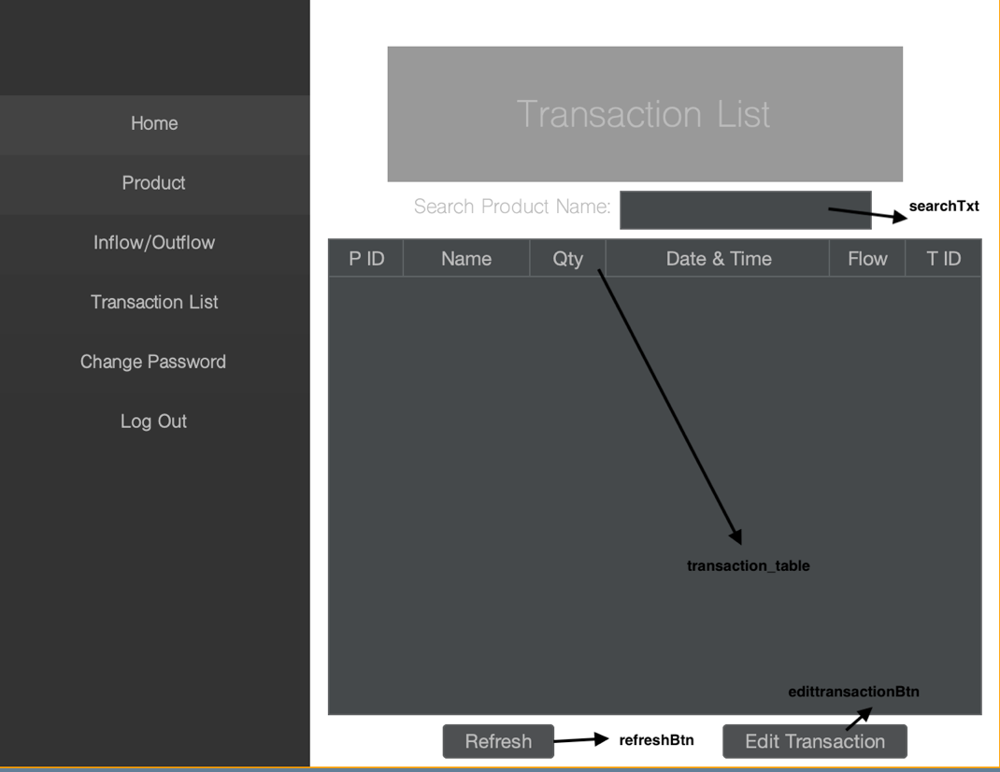
Figure 13: Data flow and Design Annotations for Transaction List Page
    - Pseudocode
// Obtain the DefaultTableModel from the JTable
DefaultTableModel tblModel = getTableModel(transaction_table)
// Create statement and execute SQL query
Statement statement = createStatement()
ResultSet rset = executeQuery("SELECT * FROM transactions_table;")

// Remove existing rows from the DefaultTableModel
while rowCount(tblModel) > 0:
removeRow(tblModel, 0)
end while

// Populate the DefaultTableModel with data from the result set
while hasNextRow(rset):
String transactionid = getString("transactionsid")
Integer tranid = parseInteger(transactionid)
String id = getString("productid")
Integer ids = parseInteger(id)
String productname = getString("productname")
String qty = getString("quantity")
Integer quantity = parseInteger(qty)
String date = getString("transactiondate")
String flowtype = getString("transactiontype")

// Create an Object array with data for each row
Object[] tbData = {ids, productname, quantity, date, flowtype, tranid}

// Add the row to the DefaultTableModel
addRow(tblModel, tbData)
end while

// Check if searchTxt is not empty
if isNotEmpty(searchTxt.getText()):
String query = searchTxt.getText()

// Apply row filter based on the searchTxt content
TableRowSorter<DefaultTableModel> tr = createTableRowSorter(tblModel)
transaction_table.setRowSorter(tr)
tr.setRowFilter(RowFilter.regexFilter(query))
end if

Edit Transaction Page
    - Diagrams and Annotations

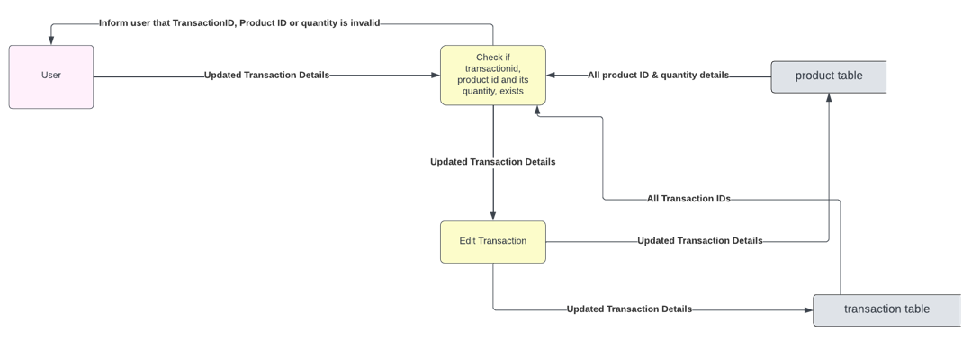
  Name: | Description:
  outflowBtn | Will change the transaction to outflow where respective product is bought/sold to  user’s customer.
  inflowBtn | Will change the transaction to inflow where  respective product is re-stocked by user.
  transactionidTxt | User enters the transactionid of the transaction that they would like to edit.
  productidTxt | The user enters the productid of the product that has been sold or stocked in this text  field.
  quantityTxt | User enters the quantity of the product that has been stocked or sold in this text field.
  transactioneditBtn | The button takes the information inputted and accordingly changes the information in  the database.
  transactiondeletepageBtn | Button takes user to transaction delete tab.
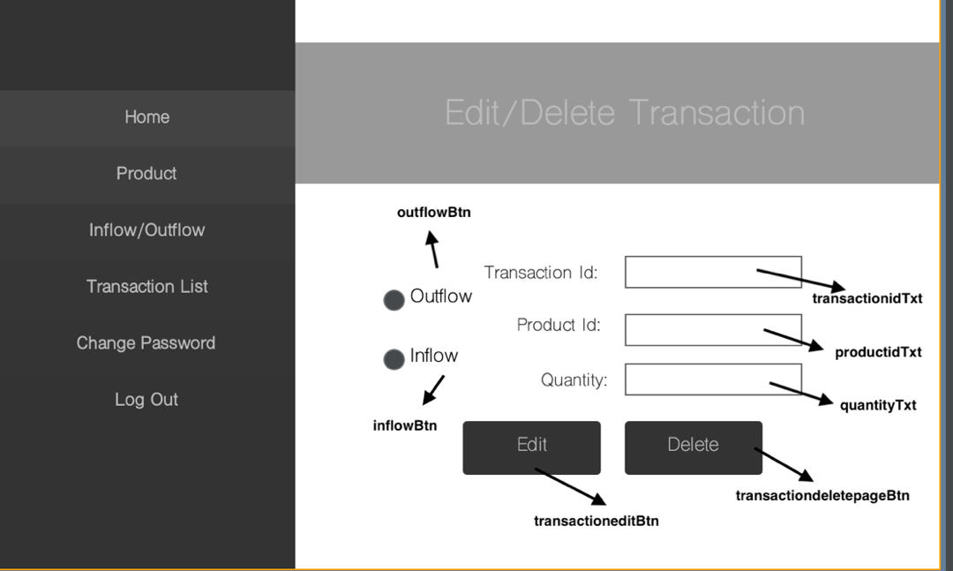
Figure 14: Data flow and Design Annotations for Edit Transaction Page
    - Pseudocode
// Get values from input fields
String tranid = transactionidTxt.getText()
String productid = productidTxt.getText()
String qty = quantityTxt.getText()
Integer count = 0

// Check if quantity entered is numeric
if qty matches "[0-9]+":
Integer quantity = parseInt(qty)

// Check if quantity is greater than 0
if quantity > 0:
try
// Establish MySQL connection
establishConnection("com.mysql.cj.jdbc.Driver", "jdbc:mysql://localhost:3306/resourceinventorymanagement", "root", "Hari2006")

// Retrieve transaction details for the given transaction ID
String retrieve = "SELECT * FROM transactions_table WHERE transactionsid='" + tranid + "';"
pstatement = prepareStatement(retrieve)
rset = executeQuery(pstatement)

// Check if transaction exists
if hasNextRow(rset):
// Retrieve transaction details
String id = getString("transactionsid")
String prodid = getString("productid")
String oldqty = getString("quantity")
String transactiontype = getString("transactiontype")
Integer oldquantity = parseInt(oldqty)

// Retrieve product details for the original product ID
String get = "SELECT * FROM product_table WHERE productid='" + prodid + "';"
productpstatement = prepareStatement(get)
productrset = executeQuery(productpstatement)

// Check if product details exist
if hasNextRow(productrset):
// Reset quantity to what it was before the transaction
String reverseqty = getString("quantity")
String initprodid = getString("productid")
Integer reversequantity = parseInt(reverseqty)

Integer addresetquantity = reversequantity + oldquantity
Integer subresetquantity = reversequantity - oldquantity

// Check if the provided product ID matches the initial product ID
if productid equals initprodid:
count = 1
end if

// Check if the transaction type is outflow or inflow
if transactiontype equals "O":
// Update quantity for product when sold
String addrevert = "UPDATE product_table SET quantity='" + addresetquantity + "' WHERE productid='" + prodid + "';"
executeUpdate(addrevert)
else:
// Update quantity for product when restocked
String subrevert = "UPDATE product_table SET quantity='" + subresetquantity + "' WHERE productid='" + prodid + "';"
executeUpdate(subrevert)
end if

// Retrieve new values for the edited transaction
String get1 = "SELECT * FROM product_table WHERE productid='" + productid + "';"
productpstatement = prepareStatement(get1)
productrset = executeQuery(productpstatement)

// Check if product details exist
if hasNextRow(productrset):
String iniqty = getString("quantity")
String productname = getString("productname")
String iniprice = getString("price")
Float initialprice = parseFloat(iniprice)
Float price = initialprice * quantity
Integer initialqty = parseInt(iniqty)
Integer finaladdqty = quantity + initialqty
Integer finalsubqty = initialqty - quantity
String date = "0"

// Check the transaction type selected by the user
if outflowBtn.isSelected():
// Check if there is enough quantity to sell
if finalsubqty >= 0:
// Update quantity for product when sold
String add = "UPDATE product_table SET quantity='" + finalsubqty + "' WHERE productid='" + productid + "';"
executeUpdate(add)

// Update transaction details
String transaction = "UPDATE transactions_table SET productid='" + productid + "', productname='" + productname + "', quantity='" + quantity + "', price='" + price + "', transactiontype='" + "O" + "' WHERE transactionsid='" + tranid + "';"
executeUpdate(transaction)

// Show success message
showMessage("Transaction Edited!")
StreamlinerLog.init()
// Log info
StreamlinerLog.logger.info("Transaction no: " + id + " edited by AdminID: " + ro)

// Navigate to the transaction list screen
navigateTo("transactionlist", ro)
else:
// Show error message when there is not enough quantity
resultLbl.setText("There is not enough quantity of the product to sell.")
if count equals 1:
// Revert product quantity update
String returnback = "UPDATE product_table SET quantity='" + reversequantity + "' WHERE productid='" + prodid + "';"
executeUpdate(returnback)
end if
end if
else if inflowBtn.isSelected():
// Update quantity for product when restocked
String add = "UPDATE product_table SET quantity='" + finaladdqty + "' WHERE productid='" + productid + "';"
executeUpdate(add)

// Update transaction details
String transaction = "UPDATE transactions_table SET productid='" + productid + "', productname='" + productname + "', quantity='" + quantity + "', price='" + price + "', transactiontype='" + "I" + "' WHERE transactionsid='" + tranid + "';"
executeUpdate(transaction)

// Show success message
showMessage("Transaction Edited!")
StreamlinerLog.init()
// Log info
StreamlinerLog.logger.info("Transaction no: " + id + " edited by AdminID: " + ro)

// Navigate to the transaction list screen
navigateTo("transactionlist", ro)
else:
// Show error message for unselected radio button
resultLbl.setText("Please select a radio button to process the transaction.")
end if
end if
else:
// Show error message for invalid ProductID
resultLbl.setText("Please Enter Valid ProductID")
end if
else:
// Show error message for invalid TransactionID
resultLbl.setText("Please Enter Valid TransactionID")
end if
end try
// Catch clause for MySQL and class error, log errors
catch SQLException e:
showMessage("Oops!, Something went wrong. Please Restart the Application and try again. Error: Unable to establish connection to database.")
end catch
else:
// Show error message for a non-positive quantity
resultLbl.setText("Please enter a quantity greater than 0")
end if
else:
// Show error message for non-numeric quantity
resultLbl.setText("Please enter a numeric value for quantity")
end if

Delete Transaction Page
    - Diagrams and Annotations

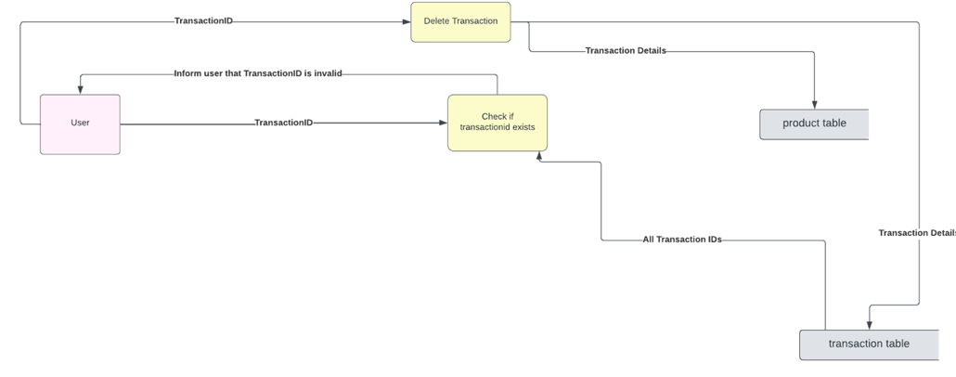
  Name: | Description:
  transactionidTxt | User enters transactionid of transaction they would like to delete
  transactiondeleteBtn | When clicked, deletes transaction which has the transaction id entered in transactionidTxt
  transactioneditpageBtn | Button takes user to transaction edit page
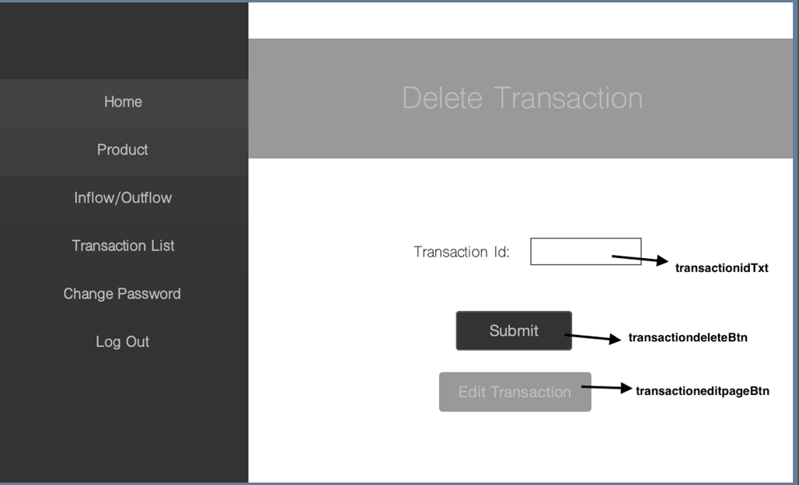
Figure 15: Data flow and Design Annotations for Delete Transaction Page
    - Pseudocode
// Get the transaction ID from the input field
transactionid = transactionidTxt.getText()

// Prepare and execute SQL query to retrieve transaction information
String transactionid = "your_transaction_id_here"
String selectQuery = "SELECT * FROM transactions_table WHERE transactionsid='" + transactionid + "';"
pstatement = con.prepareStatement(selectQuery)
rset = pstatement.executeQuery()
// Check if there is a next row in the result set
IF rset has next row THEN
// Create a statement for MySQL
statement = con.createStatement()

// Query to delete the transaction with the respective transaction ID
deleteQuery = "DELETE FROM transactions_table WHERE transactionsid='" + transactionid + "';"
statement.executeUpdate(deleteQuery)

// Close the statement
statement.close()

// Get additional details for reverting product quantity
prodid = rset.getString("productid")
oldqty = rset.getString("quantity")
transactiontype = rset.getString("transactiontype")
oldquantity = Integer.parseInt(oldqty)

// Query to get product details from product_table
getProductQuery = "SELECT * FROM product_table WHERE productid='" + prodid + "';"
productpstatement = con.prepareStatement(getProductQuery)
productrset = productpstatement.executeQuery()

// Check if product details are available
IF productrset has next row THEN
// Get current product quantity
reverseqty = productrset.getString("quantity")
reversequantity = Integer.parseInt(reverseqty)

// Calculate new product quantity based on transaction type
IF transactiontype is "O" THEN
addresetquantity = reversequantity + oldquantity
// Update product_table with new quantity
updateQtyQuery = "UPDATE product_table SET quantity='" + addresetquantity + "' WHERE productid='" + prodid + "';"
statement = con.createStatement()
statement.executeUpdate(updateQtyQuery)
ELSE
subresetquantity = reversequantity - oldquantity
// Update product_table with new quantity
updateQtyQuery = "UPDATE product_table SET quantity='" + subresetquantity + "' WHERE productid='" + prodid + "';"
statement = con.createStatement()
statement.executeUpdate(updateQtyQuery)
END IF

END IF

// Display success message
displayMessage("Transaction Deleted!")

// Log transaction deletion

// Navigate to transaction list page
navigateToTransactionList(ro)

ELSE
// Display error message for invalid TransactionID
displayError("Invalid TransactionID entered")

END IF

Change Password Page
    - Diagrams and Annotations

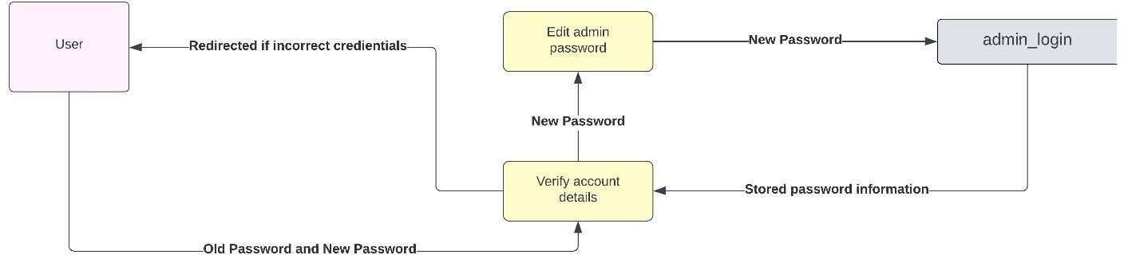
  Name: | Description:
  oldpasswordTxt | User needs to type the old password for the  account in this field to ensure security.
  newpasswordTxt | If the user would like to change the  password for the account, they can enter the new password in this text field.
  changepasswordsubmitBtn | The button submits (initiates the action  where) the new password which will change the old password in the database.
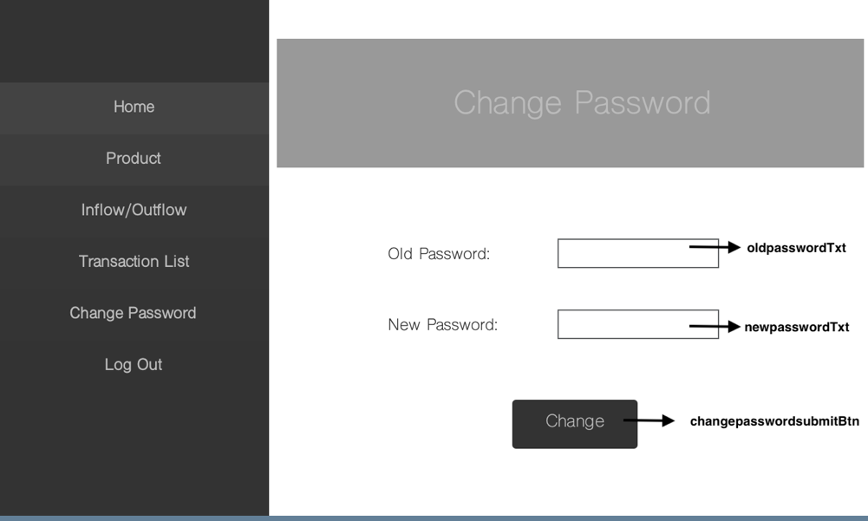
Figure 16: Data flow and Design Annotations for Change Password Page
    - Pseudocode
// Get the old password and new password from user input
String password = oldpasswordTxt.getText();
String changepassword = newpasswordTxt.getText();

// Check if the old password is not empty
IF password.length() != 0 THEN
// Check if the new password length is greater than or equal to 8
IF changepassword.length() >= 8 THEN
TRY
// Establish connection with MySQL
Class.forName("com.mysql.cj.jdbc.Driver")
String url = "jdbc:mysql://localhost:3306/resourceinventorymanagement"
Connection con = DriverManager.getConnection(url, "root", "Hari2006")

// Prepare and execute SQL query to retrieve the current password for the given user ID
String selectQuery = "SELECT Password FROM admin_table WHERE Userid='" + ro + "';"
pstatement = con.prepareStatement(selectQuery)
rset = pstatement.executeQuery()

// Loop through the result set
WHILE rset has next row DO
// Get the stored password from the result set
String storedPassword = rset.getString("Password")

// Check if the entered old password matches the stored password
IF storedPassword equals password THEN
// Check if the new password is different from the old password
IF changepassword equals password THEN
// Display message for entering a different password
resultLbl.setText("Please enter a different password")
BREAK // Exit the loop
ELSE
// Update the password to the new password
String updateQuery = "UPDATE admin_table SET Password='" + changepassword + "' WHERE Userid='" + ro + "';"
pstatement = con.prepareStatement(updateQuery)
pstatement.executeUpdate()

// Display success message
JOptionPane.showMessageDialog(null, "Password Updated!")

// Log password update information

// Navigate to the home page
new home(ro).setVisible(true)
setVisible(false)

BREAK // Exit the loop
END IF
ELSE
// Display message for invalid password
resultLbl.setText("Invalid Password Entered")

// Log password change failure
StreamlinerLog.init()
StreamlinerLog.logger.info("Password Change failed for AdminID: " + ro)
END IF
END WHILE
ELSE
// Display message for password length less than 8 characters
resultLbl.setText("New password must be at least 8 characters long")
END IF
ELSE
// Display message for empty old password
resultLbl.setText("Please enter the old password")
END IF

Test Plan:

Success Criteria | Methods of Testing | Expected Outcome
- The solution must require a login for each member of staff | - If both username and password fields are empty.  - If username field or password field is not filled in.  - Number of login attempts. | - If username, password fields or both are empty, system should inform user to enter username and password respectively.  - After 5 login attempts, the system will ask to try again in 30  minutes.
2. The solution must have a method to list/add inflow and outflow of goods | - Add invalid/non-existent product id in transaction.  - Adding negative quantities in transactions.  - Adding transactions with 0 quantity.  - Adding quantity for outflow when the quantity is not available.  - Attempting other data types for quantity and product id in transaction. | - If non-existent product id is stated, system should inform user to enter valid product id.  - Quantities entered as 0 or in negative numbers will return a message to write a positive quantity above 0.  - Any quantity that is written which is higher than the quantity available for the product will return a message to alert that the quantity is not available.  - If other data types are used, system will inform user to use integers only
3. Application must be linked to a database where inventory information will be stored | - If application is started without database, it will cause connection error.  - Any addition, editing or deletion of product, transaction, user, will be recorded on a database. | - If database is not connected, system will cause connection error, otherwise it will function as  required.
4. The user must be able to add new products (which they will sell) and delete products (which they stopped selling) | - Write new product with existing product id.  - Submit written product name with empty product  Id.  - Submit written product id with invalid manufacturing date.  - Delete a product with non-existent product id  - Submit other data types for product id. | - If new product information is added with existing product  id, it will overwrite the information  - For empty product id system will return message to write a product id respectively.  - If manufacturing date is invalid, system will return message to write a valid manufacturing date.  - If user tries to delete a product non-existent product id, system informs user that product with this id does not exist.  - If other data types are used for product id, system informs user to input integer values.
5. The solution must allow staff to view each inflow/outflow transaction that occurred | - Submit inflow  transaction and view list.  - Submit outflow transaction and view list.  - Editing a transaction  - Transaction list is organized when submitting, editing, and deleting transaction. | - After every inflow  and outflow transaction, transaction list should consist of new transaction with transaction labelled as inflow and outflow respectively.  - Editing the transaction must update the transaction and hence update the transaction list  - Transaction list should be in latest order where the first transaction done will be at the top
6. The solution must allow staff to undo each inflow/outflow transaction if information is incorrect | - Input nonexistent transaction id  - Input 0 or negative quantity.  - Submit valid/invalid product id with quantity field not filled in and vice versa. | - If a nonexistent transaction id is entered, system informs user transaction id does not exist.  - If 0 or negative integers are entered as quantity, system informs user to input only positive integer values  - If either product id or quantity field or both not filled in, system informs user to input a product id, quantity or both respectively.
7. The application must alert or record data in case of an application-breach | - Do 5 incorrect login attempts.  - Adding/Modifying or Deleting products and transactions.  - Logging In/Out of account.  - Changing password of an account. | - When 5 incorrect login attempts are done, e-mail is sent to administrator’s email regarding the situation. The application is locked for 30 minutes and the situation is also logged in a log file.  - All transactions and product alterations, logging in and logging out as well as changing password is logged onto a log file. Hence in-case of any suspicious alterations, the logs can be checked, and those specific alterations can be undone respectively.
8. The application must display the current quantity of each good | - Add inflow transaction.  - Add outflow transaction.  - Edit transactions. | - After every inflow transaction, quantity in product list should increase for the respective product and should decrease for the respective product after every outflow transaction.  - Editing transactions should correspondingly update the quantity list by removing the old transaction and replacing it with the updated transaction details.
9.The application must list which goods are in low  quantity and are in need to be restocked | - Set quantity of product through data testing.  - Check data at the limits with the quantity above 10 units (limit at which product is alerted to be restocked), below 10 units, or at 10 units. | - When the quantity of a product is at 10 units or below, the  product row in the product list for that product should be highlighted as red. Moreover, the product will be displayed in the home page as a product needing to be restocked.  - Otherwise, products with quantity above 10 units should be in the standard colour.
10. The solution must require a “change password” option for user accounts. | - Empty field is submitted.  - New password submitted is same as old password.  - Old password is not correct. | - System informs user to enter old password or new password if not filled in.  - System informs user to enter a different password as it is same as old password.  - System informs user the old password is incorrect.

